Camera Trap and Wireless Data Collection System

Achmad Ariyanto Hariman#1 Samuel William Siahaan#2 Taufiq Abdullah Salim#3

#Electrical Engineering Department, School of Electrical Engineering and Informatics, Institut Teknologi Bandung  
Ganeca 10, Bandung, 40135, West Java, Indonesia

1achmad_ariyanto@yahoo.com

2samuelsiahaan1@gmail.com

3taufiqasalim@gmail.com

Abstract**— to survey animal behaviour in a forest or a region, a system known as camera trap is commonly used. Camera trap is a system which used to take picture and video of an object in front of the system that triggered by movement. But there are some shortcomings in the system, such as long interval in data collection. Camera Trap and Wireless Data Collection System is a system that used wireless data transfer to facilitate the data collection.**

**This paper contains explanation about how to implement Camera Trap and Wireless Data Collection System. The system is divided to several subsystem, which are trap subsystem, camera subsystem, wireless data collection subsystem, image processing subsystem, data monitoring application, and power supply. The function of this system is to facilitate data collection automation from camera trap system so that less human intervention is necessary.**

Key Words— *camera trap, wireless data collection, trigger, object detection*

1. **Introduction**

Indonesian biodiversity is threatened because of many factors, some of which is caused by nature and some other caused by humans. One of the threat to Indonesian biodiversity that is caused by nature is forest fire. According to the data from department of forestry, there are more than 561 fire spots in 18 provinces in Indonesia that can cause harm to the biodiversity. Other natural factors that influence the flora and fauna in a region is humidity, temperature, and light intensity.

The second factor that threatens Indonesian biodiversity is human behaviour. According to the data from department of forestry, Indonesia has 133-million-hectare forest area, but about 65% of its area are barren. It was caused by illegal logging and illegal hunting done by human because of the high pricing in the commercial activity of log as well as animals, especially protected animal.

To solve those problems, forest ranger is needed to monitor, evaluate, and protecting the forest. Even so, with only 8000 personnel, the number is not enough for Indonesian forest area. According to Tigers Alive Initiative (TAI) 8 people is needed in every 100 km2 of forest area. To help forest ranger in doing their job, a system known as camera trap is widely used.

The now widely spread usage of camera trap still has some shortcoming, one of which is the ranger has to come to the system in person to get the data from the system and it become a problem because usually the data is only taken once a month. And the said data sometimes difficult to analyse and use to take appropriate measure because the time in the data has already long passed. For example if in the data there is an animal having abnormal condition, the ranger can’t take appropriate measure because the time has long passed.

So, camera trap and wireless data collection system will be focusing on data transfer automation that can help the ranger to get data from the system faster. Beside that, there will be additional feature such as environtmental sensor to monitor the surrounding condition, image processing to detect an object in a picture or video, and remote data monitoring application for easier monitoring.

1. **Design and Implementation**
2. **Trap subystem**

*Trap subsystem* main function is to detect if there is an object in front of the system. The trap has to be able to detect a moving object within 5m range of the sensor, sending trigger to the camera subsystem, and the delay between object detection and picture taken must be less than l second. The main algorithm used in the trap subsystem is

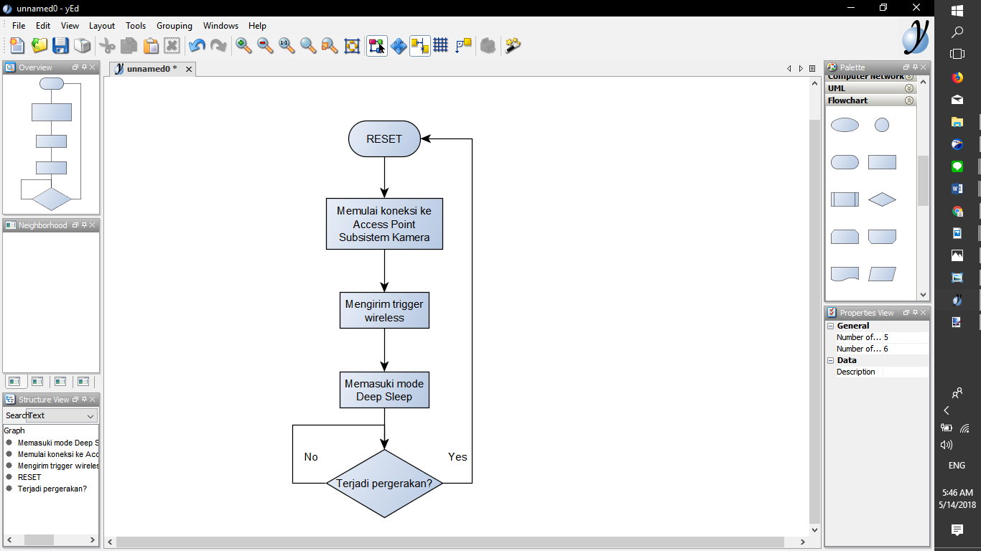

Figure II.1 Main Algorithm of Trap Subsystem

The trap subsystem is implemented wirelessly using HC-SR501 Passive Infra Red Sensor to detect object and NodeMCU to send the trigger to the camera subsystem. PIR sensor will send high output to the NodeMCU if it detects object moving in front of the sensor, then NodeMCU will send trigger to camera subsystem using MQTT protocol. MQTT protocol is used because the communication for trigger only send a little data at one time, so MQTT protocol is fast for this kind of data communication. After sending the trigger to the camera subsystem, NodeMCU will enter deep sleep mode to save power and waiting another trigger from PIR sensor to reset the NodeMCU and sending another trigger.

To reset the NodeMCU from deep sleep, a reset circuit is used, the schematic of the circuit used is shown below

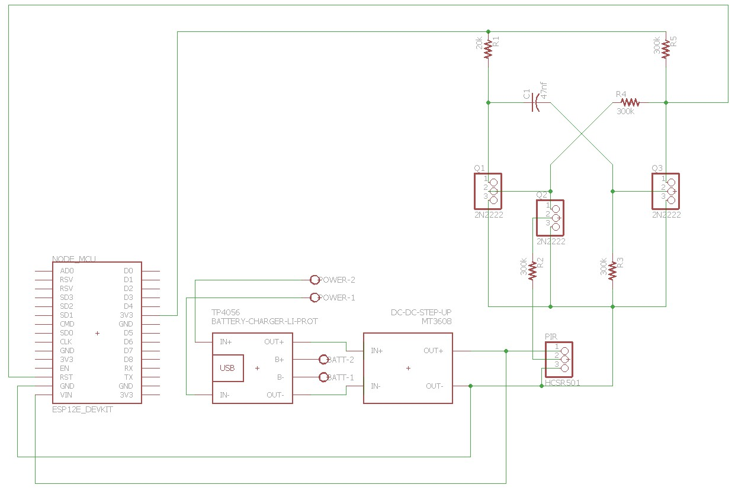

Figure II.2 Reset Circuit Schematic

The above circuit will send momentary zero pulse to NodeMCU reset pin when the PIR sensor detect object and give high pulse so that the NodeMCU will be reset and send the data

The full circuit used for the trap subsystem is described in the picture below

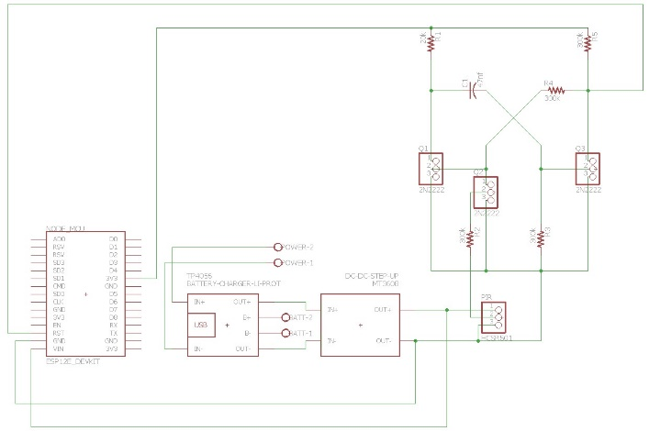

Figure II.3 Trap subsystem full schematic

Lastly, to protect the trap in the wild, a case is used. Case is made using acrylic material and a watertight seal is added to prevent water from entering the system. Below is the layout of the case

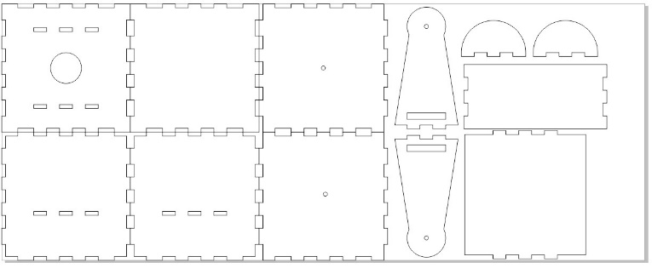

Figure II.4 Trap Case Layout

1. **Camera Subsystem**

Camera subsystem is the main component in the system because this subsystem has function to capture image and video, environment condition, and also act as a central hub for all the trap subsystem. Camera subsystem has to be able to take photo and video in day or night, take environment ciodiotion, and send the data to the Wireless data collection subsystem with minimum speed of 128 kBps. The main algorithm used to capture image in the subsystem is as shown in the picture below



Figure II.5 Image Capture Algorithm

Camera subsystem is implemented using Raspberry Pi Zero W with NoIR camera and DHT22 environment sensor. Raspberry Pi Zero W is used because of the low power consumption used. And to help the system capture image and video at night, IR LED is used. IR LED is chosen because it does not emit visible light so it will not disturb the animal. The IR LED is controlled using GPIO of the raspberry pi, using switching circuit to get higher current from the battery.

The schematic of the IR LED circuit is shown below

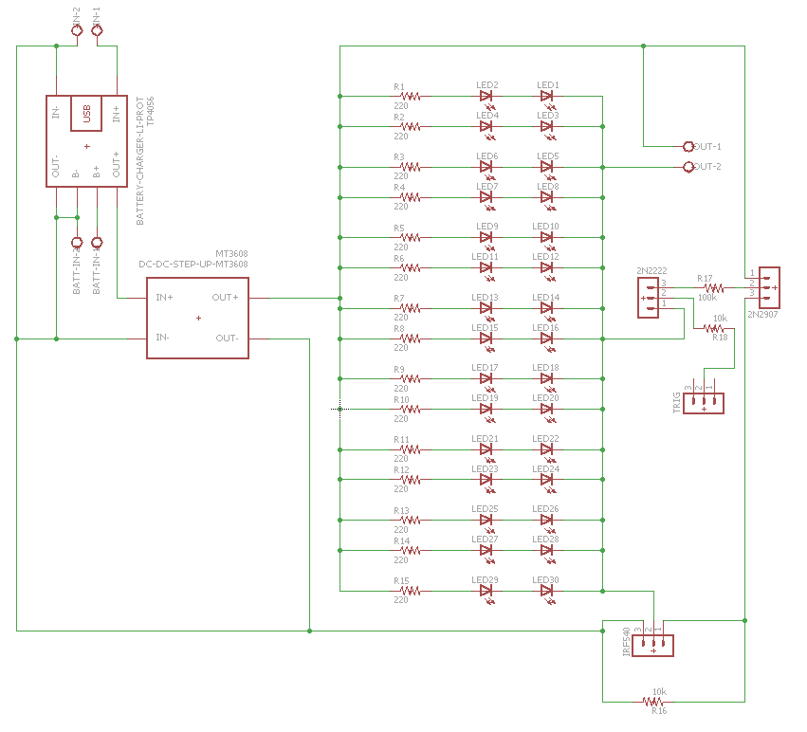

Figure II.6 IR LED Schematic

Same as trap subsystem, a case is used to protect the component from water. The layout of the case used is shown below

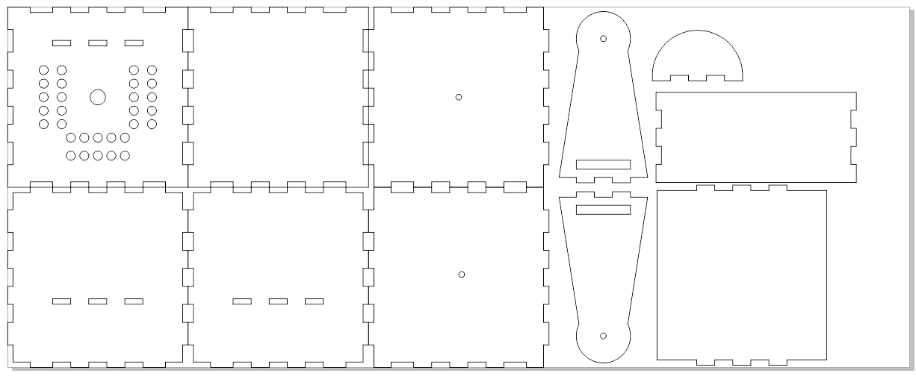

Figure II.7 Camera Case Layout

1. **Wireless Data Collector Subsystem**

Wireless data collector subsystem is used to transfer data between the camera trap system and server. The wireless data collector subsystem is designed so it can be bought using different means of transportation such as UAV (Unmanned Aerial Vehicle), UGV (Unmanned Ground Vehicle), or human.

The algorithm to execute the function is shown below



Figure II.8 Wireless Data Collector Algorithm

The system will transfer data when connected to the same network as a camera trap system. To help determining whether the transfer processed is finished or not, a buzzer is used that will sound differently when the system is still transferring the data and when the system has finished transferring the data.

1. **Image Processing Subsystem**

Image processing subsystem is used to process the acquired data form the camera trap system do determine whether an image or video has an object in it. Image processing subsystem is implemented using YOLO library, and the subsystem is trained first before it can be used to detect an object

1. **Data Monitoring Application**

Data monitoring application is used to view the data that acquired from the system and have been moved to the server. Data monitoring application is implemented in Android operating system using android studio IDE and written in Java programming language. Generally, flowchart of the application is as follow



Figure II.9 Data Monitoring Application Flowchart

1. **Power Supply**

power supply is used to power the system so the system can run automatically with little human intervention needed. the power supply has to be able to supply the system for 30 days automatically and implemented using 4 Lithium Ion Battery with nominal voltage of 3.7v and 3000mAh capacity each. The block diagram of the power supply is shown below

Figure II.10 Power Supply Block Diagram

1. **Testing and Verification**
2. **Trap Subsystem**
3. Object Detection Range

This test is used to verify the sensor furthest detection range, the test conducted in 2 condition, in ITB with light level of ±50 lux and in Tahura with light level of ±90 lux. The test result can be view on the table below.

Table III.1 Test Result in ITB

|  |  |  |  |
| --- | --- | --- | --- |
| Iteration | Range (m) | Iteration | Range (m) |
| 1 | 8.1 | **11** | 10.7 |
| 2 | 6.4 | **12** | 9.5 |
| 3 | 7.7 | **13** | 8.4 |
| 4 | 7.6 | **14** | 10 |
| 5 | 8.5 | **15** | 7.5 |
| 6 | 9.1 | **16** | 6.9 |
| 7 | 9.4 | **17** | 8.7 |
| 8 | 9.1 | **18** | 8.6 |
| 9 | 11.4 | **19** | 8.6 |
| 10 | 7.9 | **20** | 9.4 |

Table III.2 Test Result in Tahura

|  |  |  |  |
| --- | --- | --- | --- |
| Iteration | Range (m) | Iteration | Range (m) |
| 1 | 8.2 | **16** | 8.9 |
| 2 | 8.5 | **17** | 10 |
| 3 | 8.6 | **18** | 9.4 |
| 4 | 9.3 | **19** | 9.7 |
| 5 | 8.2 | **20** | 9.3 |
| 6 | 10.9 | **21** | 9.8 |
| 7 | 8.3 | **22** | 9.8 |
| 8 | 9.7 | **23** | 10.7 |
| 9 | 9.4 | **24** | 10.2 |
| 10 | 9.5 | **25** | 9.9 |
| 11 | 9.8 | **26** | 10.1 |
| 12 | 9.7 | **27** | 9.9 |
| 13 | 9.1 | **28** | 10.6 |
| 14 | 9.8 | **29** | 10.3 |
| 15 | 9.2 | **30** | 9.8 |

The data from both of the table can be summarize as minimum detection range, maximum detection range, and average range in the table below

Table III.3 Summary of Object Detection Range Test Result

|  |  |  |
| --- | --- | --- |
|  | ITB (meter) | Tahura (meter) |
| Minimum range | 6.4 | 8.2 |
| Maximum range | 11.4 | 10.9 |
| Average range | 8.675 | 9.551612903 |

From the above data, it can be concluded that the detection range is very good in both condition. The result in ITB is worse because of some factor such as light intensity and other object that can disrupt the PIR sensor.

1. Trigger Sending

This test is used to verify the delay of the delivery process of a trigger to the camera subsystem. The trigger is send using MQTT protocol. Below is the result of the test

Table III.4 Trigger Delivery Delay

|  |  |  |  |
| --- | --- | --- | --- |
| Iteration | Delay (ms) | Iteration | Delay(ms) |
| 1 | 347 | **16** | 1156 |
| 2 | 363 | **17** | 254 |
| 3 | 237 | **18** | 219 |
| 4 | 370 | **19** | 534 |
| 5 | 873 | **20** | 1371 |
| 6 | 1159 | **21** | 659 |
| 7 | 1338 | **22** | 329 |
| 8 | 656 | **23** | 554 |
| 9 | 328 | **24** | 575 |
| 10 | 230 | **25** | 741 |
| 11 | 462 | **26** | 455 |
| 12 | 483 | **27** | 365 |
| 13 | 773 | **28** | 264 |
| 14 | 1474 | **29** | 345 |
| 15 | 417 | **30** | 238 |

From the table above, the data of the delivey delay can be summarized in the table below

Table III.5 Summary of Trigger Delivery Delay

|  |  |
| --- | --- |
| MinimumDelay (ms) | 219 |
| Maximum Delay (ms) | 1474 |
| Average Delay (ms) | 598.9666667 |

From the test result show that the delay not entirely stable, the biggest factor is trying to connect to Raspberry pi network, because sometime when the Raspberry pi is doing another task, the delay to connect is increased. Nevertheless, the average delay is considered good because it most of the time the system still delivered the trigger to the camera with less than 1s delay time.

1. **Camera Subsystem**
2. Image Capture

This test is done on 2 condition of light level, ±60 and 0 lux. The test result image is shown below.

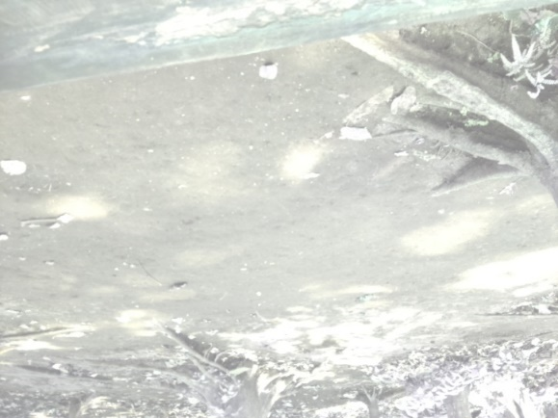

Figure III.1 Image Result in Tahura

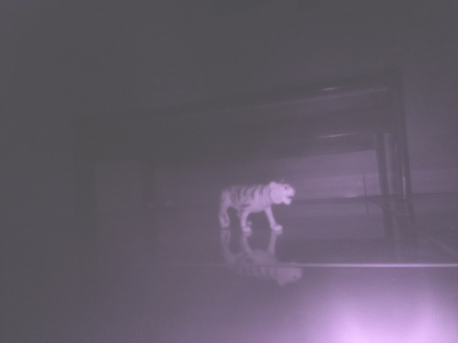

Figure III.2 Image Result in 0 Lux Level Using IR LED

From the above result, it can be said that the camera can capture image in day or night condition.

1. Image Size Test

This test is done to determine the average size of the data acquired from the system, the camera capture 30 image and 30 video 5 seconds each. Here is the result

Table III.6 Image Size

|  |  |  |  |  |  |
| --- | --- | --- | --- | --- | --- |
| No | Size (KB) | No | Size (KB) | No | Size (KB) |
| 1 | 478 | 11 | 476 | 21 | 467 |
| 2 | 481 | 12 | 475 | 22 | 470 |
| 3 | 484 | 13 | 474 | 23 | 468 |
| 4 | 484 | 14 | 474 | 24 | 471 |
| 5 | 485 | 15 | 475 | 25 | 472 |
| 6 | 480 | 16 | 474 | 26 | 472 |
| 7 | 480 | 17 | 474 | 27 | 472 |
| 8 | 477 | 18 | 475 | 28 | 471 |
| 9 | 479 | 19 | 472 | 29 | 472 |
| 10 | 477 | 20 | 472 | 30 | 472 |
| Rata-rata | | | | | 475.1 |

Table III.7 Video Size

|  |  |  |  |  |  |
| --- | --- | --- | --- | --- | --- |
| No | Size (KB) | No | Size (KB) | No | Size (KB) |
| 1 | 2325 | 11 | 2315 | 21 | 2311 |
| 2 | 2672 | 12 | 2379 | 22 | 2162 |
| 3 | 2616 | 13 | 2466 | 23 | 2313 |
| 4 | 2480 | 14 | 2469 | 24 | 2238 |
| 5 | 2357 | 15 | 2499 | 25 | 2222 |
| 6 | 2365 | 16 | 2535 | 26 | 2241 |
| 7 | 2406 | 17 | 2167 | 27 | 2393 |
| 8 | 2362 | 18 | 2198 | 28 | 2237 |
| 9 | 2626 | 19 | 2262 | 29 | 2325 |
| 10 | 2552 | 20 | 2062 | 30 | 2409 |
| Rata-rata | | | | | 2365.467 |

From the data above, the average size of image file is 475.1 KB and video size is 2365.467 KB. With the assumption there are 5 triggers a day, so

$$Data size for 1 day=\left(475,1+2365,467\right)KB ×5=14202,84 KB=14,20 MB$$

$$Data size for 1 week=14,20 MB ×7=99,4 MB$$

$$Data size for 1 month=14,20 MB ×30=426 MB$$

$$Data size for 1 year=14,20 MB ×365=5183 MB=5,183 GB$$

The storage size used is 16 GB, so the storage size is more than sufficient to store the data.

1. **Wireless Data Collection Subsystem**
2. Data transfer from Camera trap to wireless data collector

This test was done in Tahura with system distance of 5 meters. The result is as follow

Table III.8 Transfer Duration to Wireless Data Collector

|  |  |  |  |  |  |
| --- | --- | --- | --- | --- | --- |
| No | Duration (s) | No | Duration (s) | No | Duration (s) |
| 1 | 55.446 | 11 | 58.16 | 21 | 57.09 |
| 2 | 58.372 | 12 | 54.568 | 22 | 54.572 |
| 3 | 54.5 | 13 | 61.737 | 23 | 57.938 |
| 4 | 58.055 | 14 | 54.562 | 24 | 53.849 |
| 5 | 54.112 | 15 | 59.373 | 25 | 54.05 |
| 6 | 59.774 | 16 | 55.173 | 26 | 54.475 |
| 7 | 54.738 | 17 | 58.291 | 27 | 54.028 |
| 8 | 54.813 | 18 | 54.962 | 28 | 60.833 |
| 9 | 54.172 | 19 | 59.251 | 29 | 54.566 |
| 10 | 55.479 | 20 | 53.602 | 30 | 61.133 |
| Rata-rata (s) | | | | | 56.389 |
| Rata-rata(MBps) | | | | | 1.475 |

1. Data transfer from wireless data collector to server

This test was done in ITB using Hotspot LSKK wifi network. The result is as follow

Table III.9 Transfer Duration to Server

|  |  |  |  |  |  |
| --- | --- | --- | --- | --- | --- |
| No | Durasi (s) | No | Durasi (s) | No | Durasi (s) |
| 1 | 47.359 | 11 | 47.877 | 21 | 48.54 |
| 2 | 45.898 | 12 | 49.917 | 22 | 45.867 |
| 3 | 45.269 | 13 | 43.442 | 23 | 44.694 |
| 4 | 50.214 | 14 | 45.996 | 24 | 44.791 |
| 5 | 67.222 | 15 | 44.437 | 25 | 44.406 |
| 6 | 45.622 | 16 | 42.712 | 26 | 39.777 |
| 7 | 62.656 | 17 | 52.366 | 27 | 41.523 |
| 8 | 50.573 | 18 | 45.086 | 28 | 40.643 |
| 9 | 56.582 | 19 | 46.576 | 29 | 40.801 |
| 10 | 47.212 | 20 | 47.971 | 30 | 48.715 |
| Rata-rata (s) | | | | | 47.49147 |
| Rata-rata (MBps) | | | | | 1.75 |

From both of the table can be concluded that the system have fulfilled the minimum speed requirement of 128 KBps

1. **Image Processing Subsystem**

This test is used to verify if the image processing can detect object in a picture after the system has been trained. Here is the result

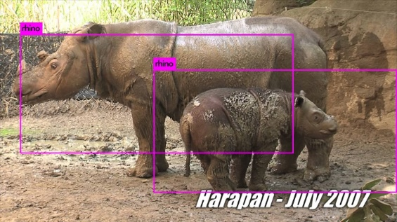

Figure III.3 Object Detection Test Result

From the picture, it can be seen that the system has ben successful to detect the object in the picture (rhino).

1. **Data Monitoring Application**

This test is used to verify the application can access the data in the server, Emulator Android Nexus 5X (Android 7.0, API24) that connected to the internet is used for this test. The result of the test can be seen below

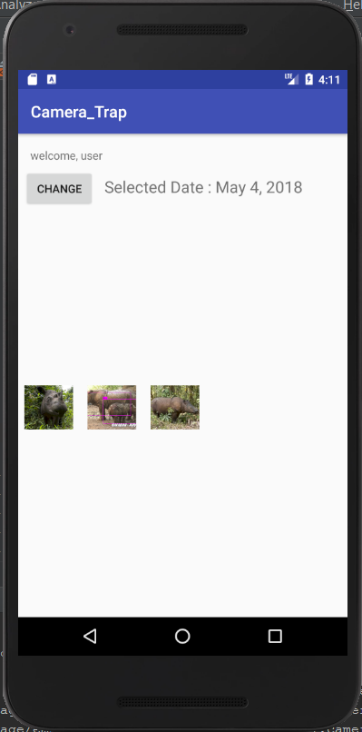

Figure III.4 Thumbnail View of Data in Appliacation

From the test, can be concluded that the application has been able to access the data in the server.

1. **Power Supply**

power supplytesting is done by measuring the current needed by the system when the system is sending trigger and when the system is idle. The result can be viewed in the table below

Table III.10 Current Needed When System is Sending Trigger

|  |  |  |  |  |  |
| --- | --- | --- | --- | --- | --- |
| No | Arus (mA) | No | Arus (mA) | No. | Arus (mA) |
| 1 | 81.8 | **11** | 82.6 | **21** | 82.6 |
| 2 | 82.1 | **12** | 81.2 | **22** | 81.9 |
| 3 | 80.8 | **13** | 82.1 | **23** | 82.7 |
| 4 | 83 | **14** | 82.9 | **24** | 82.3 |
| 5 | 80.1 | **15** | 79.7 | **25** | 81 |
| 6 | 81.9 | **16** | 82 | **26** | 82.6 |
| 7 | 79.7 | **17** | 82.3 | **27** | 80.7 |
| 8 | 81.6 | **18** | 82.6 | **28** | 83 |
| 9 | 82.3 | **19** | 81 | **29** | 80.9 |
| 10 | 82.3 | **20** | 80.3 | **30** | 82.1 |
| Rata-rata (mA) | | | | | 79.7 |

When the system is idle, the current draw from the circuit is below 10 mA, assuming there are 5 triggers a day and each trigger need 5 seconds process time, then

$$Power needed for 1 day$$

$$=\left(79.7×\frac{25}{3600}\right)+\left(10×\frac{86375}{3600}\right)=250.5mAh$$

$$Power needed for 1 month$$

$$=250.5mAh×30=7214.5 mAh=7.2 Ah$$

So, by using 4 parallel batteries, the system can be used automatically for 47 days.

1. **Conclusion**

Overall, the subsystem in Camera Trap and Wireless Data Collection System have been tested and verified successfully and the function of the system to help collecting data automatically has been achived.

Reference

1. Ancrenaz, Marc, dkk. 2012. *Handbook for Wildlife Monitoring Using Camera-Traps.* Malaysia: BBEC II Secretariat.
2. Tim Monitoring Badak Indonesia. 2014. *Panduan Survei dan Monitoring Badak Sumatera: Teknik Okupansi, Kamera Otomatis, dan Analisis DNA*. Kementrian Kehutanan, Jakarta.
3. Jones, Dave. 2014. *picamera*. <http://picamera.readthedocs.io/en/release-1.12/index.html>. Diakses pada tanggal 3 April 2018
4. Hinrichs, Jeff. 2016. *pysftp*. <https://pysftp.readthedocs.io/en/release_0.2.9/>. Diakses pada tanggal 4 Maret 2018.
5. Hellmann, Doug. 2017. *multiprocessing Basics*. <https://pymotw.com/2/multiprocessing/basics.html>. Diakses pada tanggal 13 Mei 2018.
6. NodeMCU Datasheet